Pointer is a very important concept of programming. A pointer could point to the beginning of an array

Which is the head ( first address of an array ), the content of a pointer is the address which the pointer points to. So C++ include * and & instructions to work with address.

1. * means you want to take the “**value**” from the location(address) it store
2. & means you want the “**address**” which a variable or a pointer store in.

Let’s see the example↓ ( a pointer point to an array )

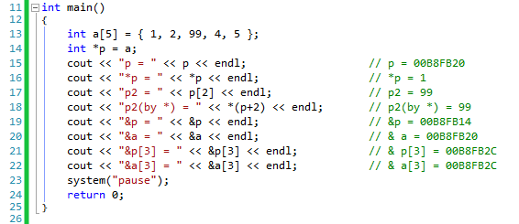

A pointer can also point to any kinds of variable (int, char, double, …) and an **object** as well !

For example, we know string is actually an object ( string is defined by class string, it’s a class )

Here is the example of pointer points to a string.

